Photoshop Review 1 – 3
This review guide will review techniques from the beginning chapters of Adobe Photoshop Classroom in a Book.

REVIEW ASSIGNMENT #1
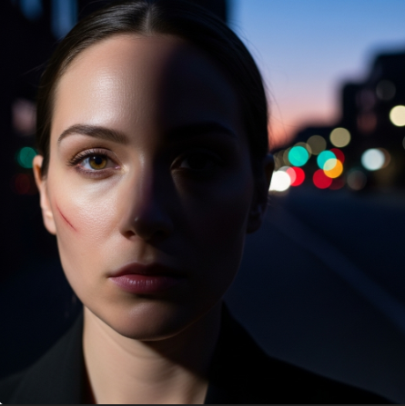
Copy and paste the above image into photoshop and follow the instructions below.
REVIEW ASSIGNMENT #1
Step 1: Straighten the Image
The first thing you'll want to do is correct the crooked horizon line.
- Select the Crop tool (C) from the toolbar.
- In the Options bar at the top, select the Straighten tool.
- Click and drag a line across the horizon or another element in the photo that should be straight, like the building tops.
- Photoshop will automatically rotate the image to straighten the line you drew.
- Press Enter to commit the crop.
Step 2: Remove the Scratches and Distracting Objects
Now let's clean up the distracting elements using a content-aware tool.
- Select the Remove tool from the toolbar.
- Adjust the brush size to be slightly larger than the scratch on her cheek.
- Brush over the scratch to remove it. You can also use this tool to remove the traffic light in the background.
Step 3: Correct the Lighting
The goal here is to balance the light so the overexposed side is toned down and the shadowed side is brightened.
- Go to Image > Adjustments > Shadow/Highlights.
- Increase the Shadows amount to reveal details in the dark side of her face.
- Decrease the Highlights amount to bring back detail in the bright side of her face.
- Use the Tone and Radius sliders to fine-tune the effect.
- Click OK when you're happy with the results.
Step 4: Refine Color and Tone
Now let's use a non-destructive method to give the image a better overall feel.
- In the Layers panel, click the Create new fill or adjustment layer icon (the half-filled circle).
- Choose Curves.
- The Properties panel will appear with the Curves graph. Click in the center of the diagonal line and drag it slightly upward to brighten the overall image, or downward to darken it.
- To increase contrast, drag the bottom-left point slightly to the right and the top-right point slightly to the left.
- Experiment with the different color channels in the Curves panel (Red, Green, and Blue) to adjust the color cast of the image until it looks natural.

REVIEW ASSIGNMENT #2
Copy and paste the images below into photoshop and follow the instructions below.
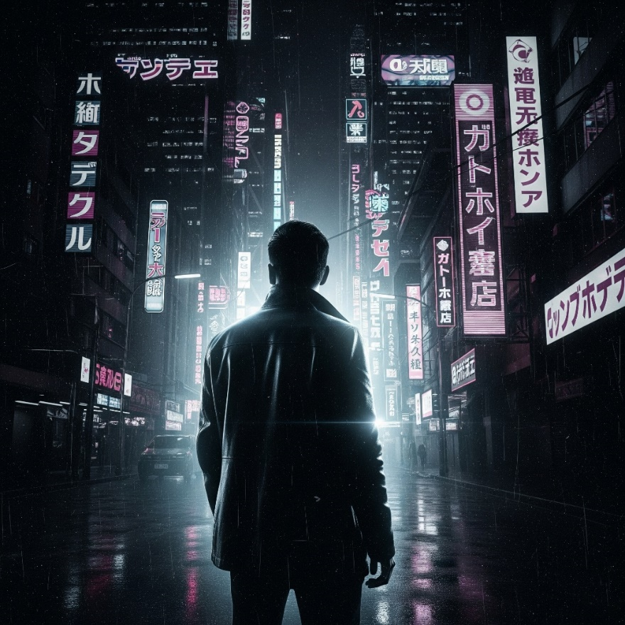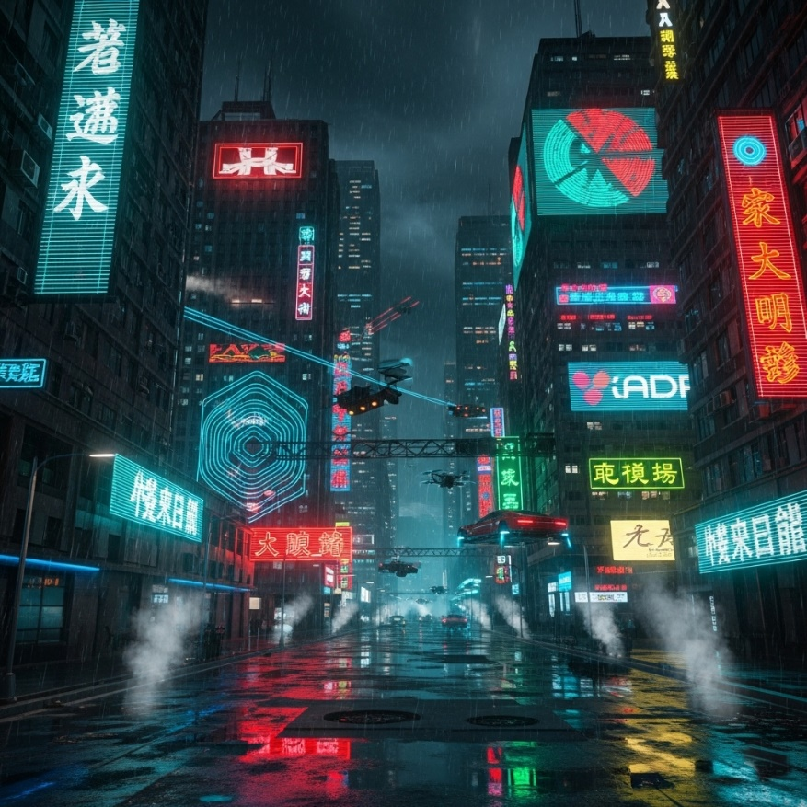
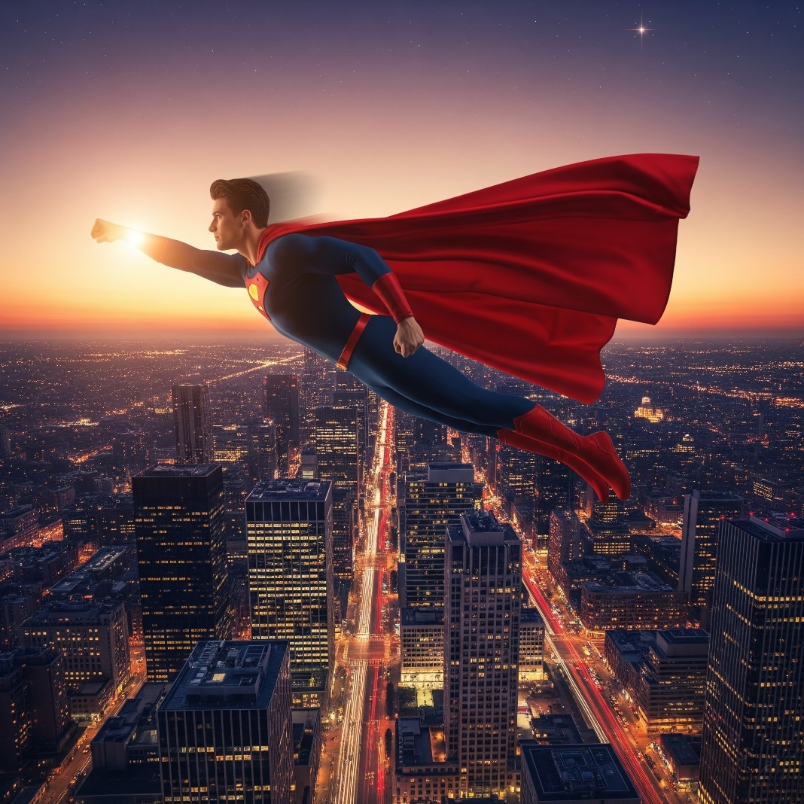
Goal: Integrate the flying superhero into the futuristic neon city scene, matching lighting, color, and atmosphere.
Starting Layers:
- "City Background" Layer: The futuristic neon city image.
- "Superhero" Layer: The isolated superhero on a transparent background.
- “Man in Black” Layer: The man in black on a transparent background
Step 1: Place the Superhero into the City Scene
- Open the City Background image, the Superhero image, and the Man in Black image in Photoshop.
- In the Superhero document, remove the background and ensure the superhero is on its own layer.
- Drag the "Superhero" layer from its document tab over to the "City Background" document tab, and then release it. This will place the superhero on a new layer above the city.
- With the "Superhero" layer selected, press Ctrl+T (Windows) or Cmd+T (Mac) to activate the Free Transform tool.
- Resize and Reposition: Drag the corner handles to scale the superhero to an appropriate size for the city. Drag inside the bounding box to move the superhero to your desired position (e.g., flying down the street).
- Press Enter to commit the transformation.
Step 2: Adjust Superhero Lighting and Color to Match the City
The city has a dark, neon-lit, cool tone. The superhero needs to reflect this.
- Shadows/Highlights Adjustment (Basic Tone Match):
  - With the "Superhero" layer selected, go to Image > Adjustments > Shadow/Highlights.
  - Adjust the Shadows and Highlights sliders to reduce the dynamic range of the superhero, making it less bright than its original form and more aligned with the city's darker tones. Aim to bring out detail in the darker parts of his suit while preventing the bright areas from being overexposed.
  - Click OK.
- Color Balance Adjustment (Cool Tones):
  - With the "Superhero" layer selected, go to Image > Adjustments > Color Balance.
  - In the Midtones setting, drag the slider slightly towards Cyan and Blue to introduce the cool neon tones of the city onto the superhero.
  - You might also make slight adjustments to Shadows and Highlights in the Color Balance panel for further refinement.
  - Click OK.
Step 3: Add Neon Glow and Reflection
- Create Glow Effect (on Superhero Layer):
  - Right-click (or Ctrl-click) on the "Superhero" layer in the Layers panel and choose Blending Options...
  - Select Outer Glow.
  - Set the Blend Mode to Screen.
  - Click on the color swatch and choose a bright neon color (e.g., electric blue, bright pink, or yellow-green) that matches some of the prominent neon signs in the background.
  - Adjust the Spread and Size sliders to create a subtle glow around the superhero that mimics the ambient light from the neon signs.
  - Select Inner Glow.
  - Set the Blend Mode to Soft Light or Overlay.
  - Choose a similar neon color.
  - Adjust the Choke and Size to create a very subtle inner illumination, suggesting light reflecting off his suit.
  - Click OK.
- Add a Lens Flare (Source of Power):
  - Create a new blank layer above the "Superhero" layer (Layer > New > Layer).
  - Fill this new layer with black (Edit > Fill > Contents: Black).
  - Change the layer's Blend Mode to Screen. (This will make the black disappear, allowing the lens flare to show through.)
  - Go to Filter > Render > Lens Flare...
  - Choose a flare type (e.g., 105mm Prime) and position the crosshair over the superhero's hand or wherever you want the light source to originate.
  - Adjust the Brightness.
  - Click OK.
Step 4: Final Atmospheric Adjustments
These steps help to unify all elements and add a cinematic touch.
- Add a "Rain" or "Dust" Overlay:
  - You could import an image of rain or subtle atmospheric particles (e.g., dust, light snow) as a new layer.
  - Place this layer at the very top of your layer stack.
  - Change its Blend Mode to Screen to make the black areas transparent, leaving only the rain/particles visible.
  - Adjust the Opacity of this layer to your liking.
- Overall Color Grading with an Adjustment Layer:
  - Click the Create new fill or adjustment layer icon (half-filled circle) in the Layers panel.
  - Choose Color Lookup.
  - Experiment with different 3DLUT File presets (e.g., "Crisp Warm," "Fuji F125 Kodak 2395," "NightFromDay.cube") to apply a final cinematic color grade to the entire image. Adjust the opacity of this adjustment layer to lessen its effect if needed.
Adding and Modifying the "Man in Black"
Starting Layers (from previous steps):
- "City Background" Layer
- "Superhero" Layer (with its adjustments and glow)
- "Lens Flare" Layer
- "Rain/Dust Overlay" Layer
- "Color Lookup" Adjustment Layer (keep it on top for final look)
New Layer Needed:
- "Man in Black" Layer: The isolated "man in black" on a transparent background.

Step 5: Place the "Man in Black" into the Composite
- Open the image of the "Man in Black" in Photoshop. Make sure he is already isolated on a transparent background (as if you've already completed the selection techniques from Chapter 3).
- Drag the "Man in Black" layer from its document tab over to your composite document tab, and then release it. This will place him on a new layer, ideally below the "Superhero" layer but above the "City Background" layer.
- With the "Man in Black" layer selected, press Ctrl+T (Windows) or Cmd+T (Mac) for Free Transform.
- Resize and Reposition: Scale him to a realistic size relative to the city street and place him towards the foreground, looking up at the superhero. You might need to make him quite large to give a sense of perspective.
- Press Enter to commit the transformation.
Step 6: Adjust Lighting and Shadows to Match the City
The "Man in Black" is silhouetted, which fits the dark, neon-lit environment. However, we need to ensure his edges and any subtle details match the city's mood.
- Darken and Boost Contrast:
  - With the "Man in Black" layer selected, create a new Levels adjustment layer directly above it (Layer > New Adjustment Layer > Levels).
  - To ensure this adjustment only affects the "Man in Black," Alt-click (Option-click on Mac) between the Levels layer and the "Man in Black" layer in the Layers panel (a small down arrow will appear) to create a Clipping Mask.
  - In the Levels Properties panel, drag the black output slider (bottom left) to the right to deepen his shadows further.
  - Drag the gray midtone slider (middle) to the left to darken him overall, or to the right to slightly brighten, depending on how much detail you want to preserve.
  - You can also drag the black input slider (top left) to the right to crush the blacks even more for a stronger silhouette.
- Add Subtle Edge Lighting (Matching Neon):
  - Create a new blank layer above the "Man in Black" (and above its Levels clipping mask). Clip this new layer to the "Man in Black" as well.
  - Change the Blend Mode of this new layer to Screen or Soft Light.
  - Select a soft-edged brush (B) and pick a neon color from the city (e.g., bright blue or magenta) using the Eyedropper tool (I).
  - Gently brush along the edges of the "Man in Black" where you expect light from the neon signs to catch him, giving him a subtle rim light. Reduce the brush Opacity to 10-20% for a subtle effect.
Step 7: Integrate with the Ground Reflection (Advanced Compositing)
This step makes him look like he's actually standing on the wet, reflective street.
- Duplicate and Flip:
  - Duplicate the "Man in Black" layer (Ctrl+J or Cmd+J).
  - With the duplicated layer selected, go to Edit > Transform > Flip Vertical.
  - Press Ctrl+T (or Cmd+T) and drag the flipped man downwards so his feet align with the original man's feet, creating a reflection. Press Enter.
- Distort and Blur Reflection:
  - With the flipped layer selected, go to Edit > Transform > Distort.
  - Drag the bottom corners of the bounding box outwards to make the reflection spread wider, mimicking the perspective of reflections on a wet surface.
  - Go to Filter > Blur > Gaussian Blur. Apply a significant blur (e.g., 5-15 pixels) to soften the reflection.
  - Adjust the Opacity of the reflection layer (e.g., 30-60%) to make it look semi-transparent and less distinct.
- Mask the Reflection:
  - Add a Layer Mask to the reflection layer (click the "Add layer mask" icon at the bottom of the Layers panel).
  - Select a soft-edged black brush (B).
  - Paint on the layer mask to gently fade out parts of the reflection, especially closer to the man's feet and where the wetness might be less pronounced.
Step 8: Final Adjustments (Order of Layers)
Ensure your layers are in a logical order. The overall "Color Lookup" adjustment layer (if you created one in the previous tutorial) should typically be at the very top of your layer stack to affect all underlying layers and unify the final look.
By carefully following these steps, the "Man in Black" will be convincingly integrated into your dynamic, neon-lit superhero composite!

REVIEW ASSIGNMENT #3

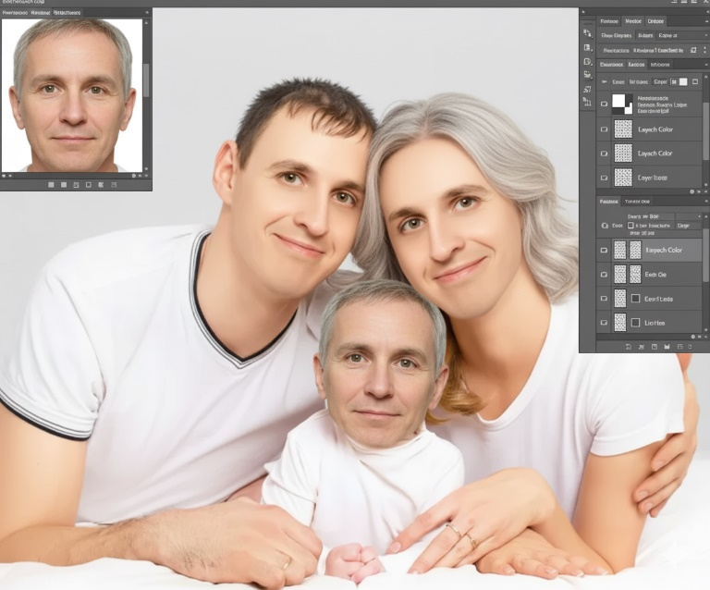

Swapping Faces for a Meme in Photoshop
This tutorial will guide you on how to replace the faces in the family image with a face using techniques suitable for a meme.
Goal: Replace the faces of the mother, father, and toddler with your chosen face to create a funny meme.
Starting Layers:
- "Family Base" Layer: The provide family image (or one of your choice).
- "New Face Source" Image: The image of the face you want to use.

Preparation: Getting Your New Face Ready
- Open the New Face Source Image: Open the image with the chosen person's face in Photoshop.
- Select the Face: Use the Quick Selection tool (W) or the Lasso tool (L) to make a loose selection around the entire face (including some hair and chin area). It doesn't have to be perfect, as we'll refine it.
- Copy the Face: Press Ctrl+C (Windows) or Cmd+C (Mac) to copy the selected face.
- Paste into Family Document: Go back to your "Family Base" document. Press Ctrl+V (Windows) or Cmd+V (Mac) to paste the face onto a new layer. This will be your first "New Face" layer.

Process for Each Face (Father, Mother, Toddler):
You will repeat the following steps for each of the three family members. Let's start with the father.
Step 1: Place and Scale the New Face
- Select the "New Face" layer you just pasted.
- Press Ctrl+T (Windows) or Cmd+T (Mac) to activate the Free Transform tool.
- Resize and Reposition:
  - Drag the corner handles while holding Shift (to maintain proportions) to scale the new face to roughly the size of the father's face.
  - Drag inside the bounding box to move the new face over the father's face.
  - Adjust the Opacity of the "New Face" layer (in the Layers panel) to about 50%. This allows you to see the original face underneath, helping you align features like eyes, nose, and mouth.
  - When satisfied with the size and position, press Enter to commit the transformation.
  - Set the Opacity of the "New Face" layer back to 100%.
Step 2: Refine the Face Shape with a Layer Mask
- With the "New Face" layer selected, click the Add layer mask icon (the white rectangle with a circle in the middle) at the bottom of the Layers panel. A white mask thumbnail will appear next to the face layer's thumbnail.
- Select a soft-edged brush (B). Make sure your foreground color is set to black (press D then X).
- Paint to Hide: With the layer mask thumbnail active (click it if it's not), paint with black on the canvas to hide parts of the new face layer that extend beyond the desired face shape. Focus on blending the edges, making sure the new face fits naturally onto the head. You'll reveal parts of the original head/hair/neck.
- If you accidentally hide too much, switch your brush color to white (X) and paint on the mask to reveal parts of the new face again.
Step 3: Adjust Color and Tone to Match the Body
This step helps the new face blend seamlessly with the original body's skin tone and lighting.
- With the "New Face" layer selected, go to Image > Adjustments > Match Color...
- In the "Match Color" dialog box:
  - For Source, select your "Family Base" document.
  - For Layer, select the original layer of the person whose face you are replacing (e.g., the original father's layer, if you placed it on a separate layer before starting). If the family is all on one background layer, just select that layer.
  - Adjust the Luminance, Color Intensity, and Fade sliders until the new face's skin tone closely matches the skin tone of the neck/body.
  - Click OK.

- Optional: Curves/Levels Adjustment Layer (for more control):
  - Add a Curves or Levels adjustment layer directly above the "New Face" layer.
  - Alt-click (Option-click on Mac) between the adjustment layer and the "New Face" layer to create a Clipping Mask. This ensures the adjustment only affects the new face.
  - Adjust the sliders in the Properties panel to fine-tune the brightness, contrast, and color balance of the new face until it looks perfectly integrated.
Step 4: Repeat for Mother and Toddler
- Repeat Steps 1-3 for the mother and then for the toddler, each time pasting a new instance of your other face onto a new layer.
- For the toddler, you'll need to scale the face down significantly.
- Pay close attention to alignment and blending for each individual.

